**Introduction to EC2**

EC2 stands for Amazon Elastic Compute Cloud.

EC2 is a web service that provides secure, resizable compute capacity in the cloud and allows you to run application programs in the computing environment.

EC2 Features & Advantages

Features of EC2:

EC2 provides you to pay only for the resources that you actually use and get ready to use in a short time.

Advantage of EC2:

Elasticity: Capacity needs can be arranged within minutes.

Control: You can create, stop or terminate instances via EC2 console, CLI or SDKs easily.

Reliability: EC2 Service Level Agreement (SLA) of 99.99% is committed by Amazon.

### EC2 Basic Components

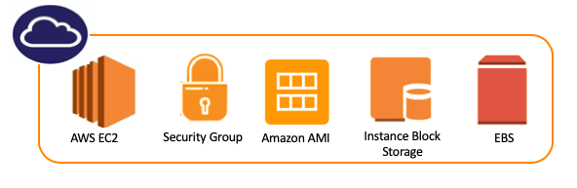

Virtual computing machines are known as Instances in AWS environment,

Pre-configured templates for your instances, known as Amazon Machine Images (AMIs), that package the bits you need for your server (including the operating system and additional software),

Generally, storage components for EC2 are known as Amazon EBS Volumes and Instance Block Storage,

A firewall that enables you to specify the protocols, ports, and source IP ranges that can reach your instances using Security Groups,

**AWS Instances**

Types of Instances: Pricing Model and Purpose Model.

Pricing Model

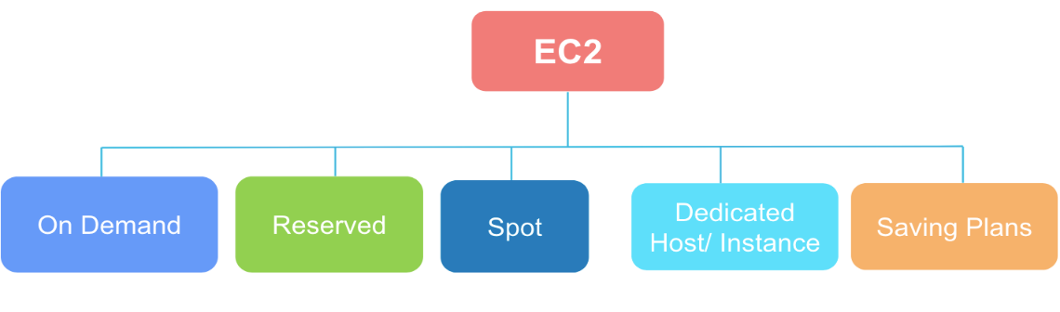

On-Demand

* + - Pay as you go, no commitment, price is fixed and pre-determined
* EC2 virtual machines are available on request.
* Each virtual machine model has an hourly price.
* This method is used for usually short-term needs, especially testing and temporary needs.

Reserved Instance (RI)

* 1- or 3-years commitment, 30%-75% price advantage, Partial upfront or all upfront, capacity is reserved
* Scheduled Reserved Instance: Provides you to make the purchase over 24 hours. For example, we have an application that works only between 10:00 and 19:00 in the morning. In advance, we could buy a 24-hour RI but,  In advance, we could buy a 24-hour RI but, thanks to the Scheduled Reserved Instance, you can buy an instance only between these hours now.

### Spot Instance

* **Spot Instance** (Cost advantage up to 90%)
* Almost all types of servers in EC2 have an On-Demand price, which is a fixed price, and there is a spot price that changes according to this idle capacity and changes in seconds. Just like the stock market.
* The machine **runs when the price falls below the target price**.

The only **downside** is that the machine automatically **shuts down if the price exceeds that target price**.

### Dedicated Host

* A **physical server** the whole capacity of with EC2 instance is dedicated to your use.
* A Dedicated Host consists of Dedicated Instance capacities according to your needs. You may choose only one Dedicated Instance also.
* In some cases, using a dedicated host may be a legal necessity or a requirement for application licenses.
* Also regulations may require that customer information relating to certain special issues to be stored in this way.

### Saving Plans

* Savings Plans is a flexible pricing model that helps you save up to 72 percent on Amazon EC2 and some other computing services.
* Savings Plans provide you lower prices for your Amazon EC2 usage in exchange for a commitment to a consistent usage amount (measured in $/hour) for a one or three-year term.
* For example, if you commit to $10/hour of computing usage, your usage is charged at your Savings Plans rate up to $10. Any usage beyond your Savings Plans commitment is charged at your regular On-Demand rates.

### Purpose Model

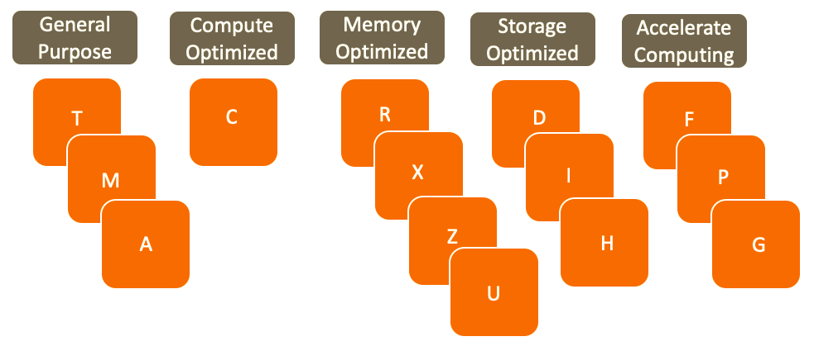

**General Purpose:**

* Requiring workloads such as WEB servers, microservices, cache fleets, distributed data stores, and development environments.
* There are T, M and A options that we can use for standard and application needs.
* This is the most commonly used server type.

**Compute Optimized:**

* Preferred when you need High-performance web servers scientific modeling, batch processing, high computing, machine learning, and multiplayer coding.

Memory Optimized:

* It is used in situations requiring a high-performance database, real-time large data analytics, and high memory usage.
* There are R, X, Z and U type instances in this category

Storage Optimized:

* There are D, H and I type of instances in this category. It is the best used for the fast disk structures we need in NoSQL databases or data warehouse solutions.

Accelerated Computing:

* It is preferred when you need machine learning, deep learning calculation, fluid dynamics, and analysis.

### **Code Definition of Instance Type**

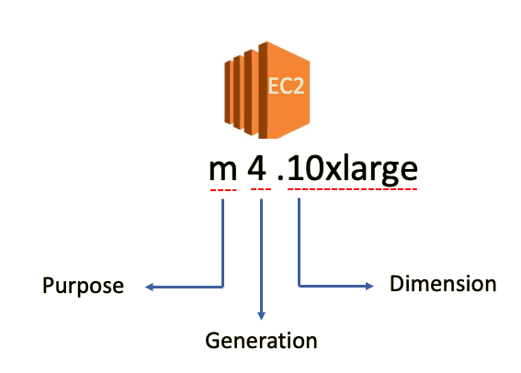

* **m** stands for its purpose. It means this EC2 is General Purpose instance.
* the number of **4** comes which indicates instance generations.
* **10xlarge** shows the dimension of instance.

### Choosing an Instance

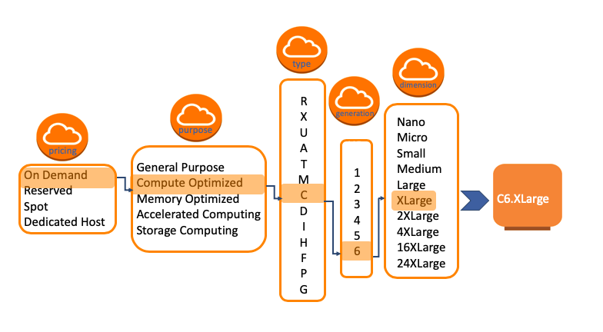

## EC2 Volumes

## EC2 Block-Based Virtual Disks

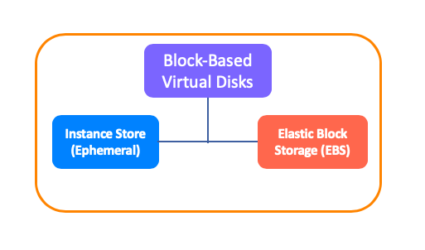

* Volume is a durable storage device that you can attach to instances. It is a location in which the associated machine stores its data or loads its applications.
* AWS serves 2 basic volume options for costumers in the Block-Based Storage category. These are Instance Store (Ephemeral) and Elastic Block Storage (EBS).

### Virtualization in EC2

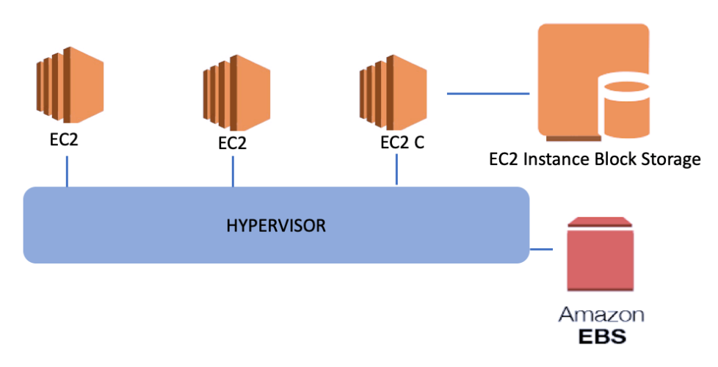

* In the virtualization environment, we have one physical server and a virtualization software on it, as seen in the figure above.
* We call this driver and software layer as a **Hypervisor**. The hypervisor is a system that ensures that all information within its body can be accessed by all connected machines or storage devices.
* The systems connected **directly to the hypervisor** and accessible to each machine associated with hypervisor we mentioned above is called EBS, **Elastic Block Storage**, in the AWS.
* Thus, if one of the physical servers fails, the virtual machine configurations running on it pass to the other physical server and continue to operate without interruption.
* But, instead of being connected directly to hypervisor, **Instance Block Storage** is **connected to only the related server** on which the virtual machine is running.

### Instance Block Storage (Ephemeral)

* The storage method that uses disks directly connected to the physical server on which the virtual machine is running. It may have SSD or magnetic HDD hard disk.
* The **advantage** of this model is that it provides high access speed and very low latency because it is directly on the physical server to which the virtual machine is connected.
* The **disadvantage** is that if the virtual machine shuts down in some way, all data here is lost. If something happens to the underlying physical machine or you turn off the virtual machine, the data on these disks cannot be accessed.

### EBS (Elastic Block Storage)

* EBS is the storage solution that can be attached to a virtual machine and can be installed in an operating system/application.
* EBS also provides a 99.999% accessibility guarantee and replicates data to multiple physical devices within the same AZ, including SSD or HDD based disk infrastructures.
* If you create a Windows or Linux EC2 instance EBS volume can be attached as Root device of volume automatically.Top of Form

### EBS Volume Types

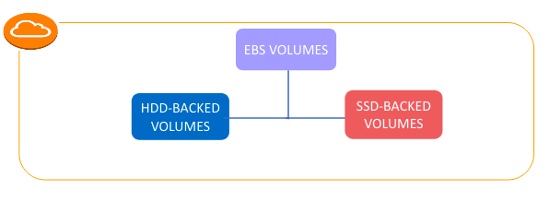

* **Solid state drives (SSD):** Optimized for transactional workloads involving frequent read/write operations with small I/O size, where the dominant performance attribute is IOPS.
* **Hard disk drives (HDD):** Optimized for large streaming workloads where the dominant performance attribute is throughput.

### IOPS and Throughput

* IOPS stands for **I**nput/Output **O**perations **P**er **S**econd.
* It is a common performance measurement used to test computer storage devices like HDD or SSD etc.
* IOPS is a value that specifies how many reads and writes can be made to a disk per second.
* **Throughput** is the value that specifies how many MB of data transfer per second is allowed to a storage system.
* While IOPS is related to the functional **speed** of the disk, Throughput is related to processing **capacity**.
* Throughput can be affected by IOPS, packet size and also network protocol.

## EC2 Volumes

### SSD Type EBS

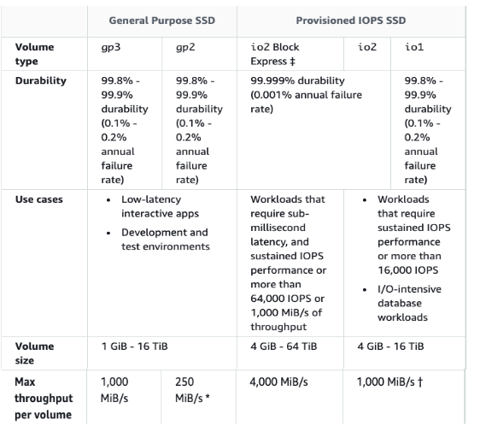

### HDD Type EBS

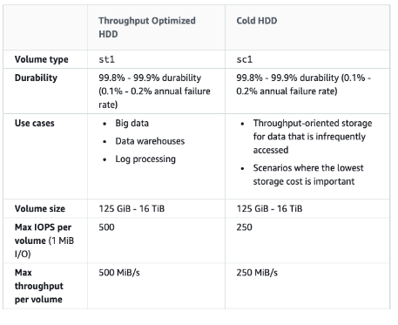

Bottom of Form